DeerCamp Legacy Collection – Origins
- 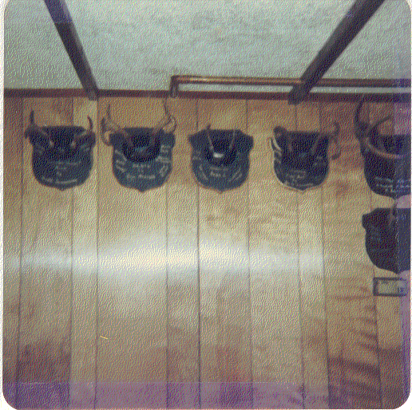
Cornell, WI – Deer Den

- 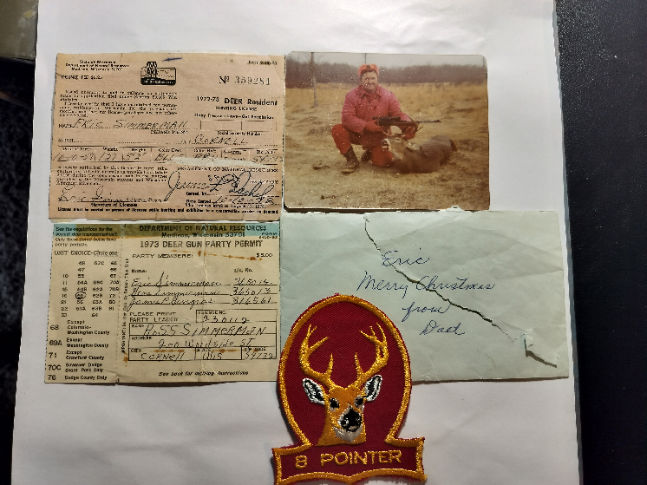
Cornell, WI – hunting memorabilia

- 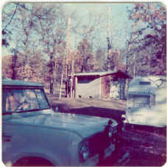
Neillsville, WI – Snyder Park, Clark County

- 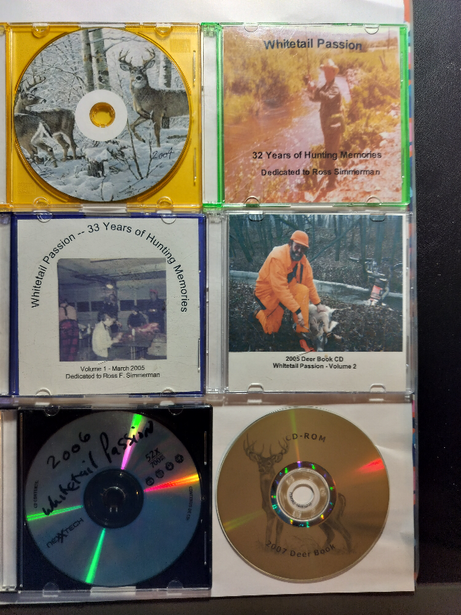
Early DeerCamp CDs

- 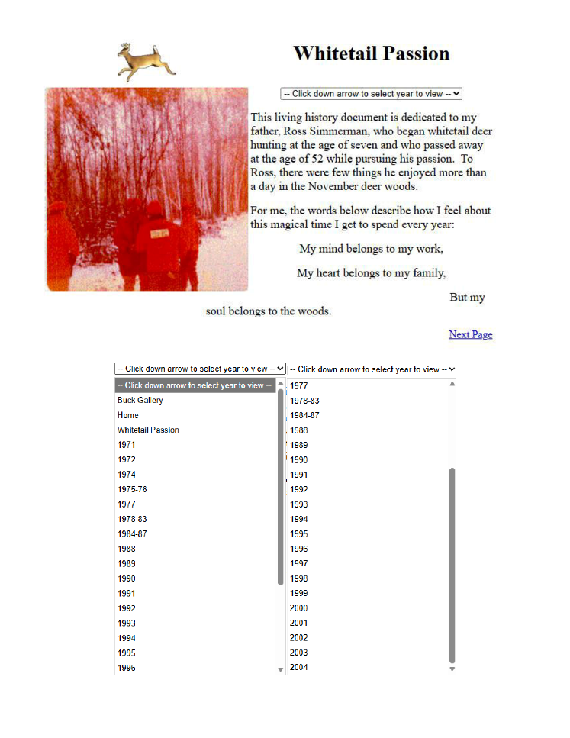
DeerCamp CDs – Expanded Years

